**8fit Data analyst case solution**

**Question 1. Where to invest? ios or android?**

**Solution:**

Aiming to analyse platforms performance, I would like to add two new KPIs:

* CAC (Customer Cost of Acquisition): Total_Spending/Total_subscription_count
* NEPC (Net Earning per Customer): Revenue_per_Customer - CAC. In fact, NEPC shows how much we made at the end from each customer. It is a profitibility indicator, the higher it is the better the performance would be.

*As there is a potential belief that ios users are more profitable to businesses I defined NEPC to explore the reality with a higher resulotion.*

Below Visualizations help us to have a clearer idea on both platforms' perfromance.

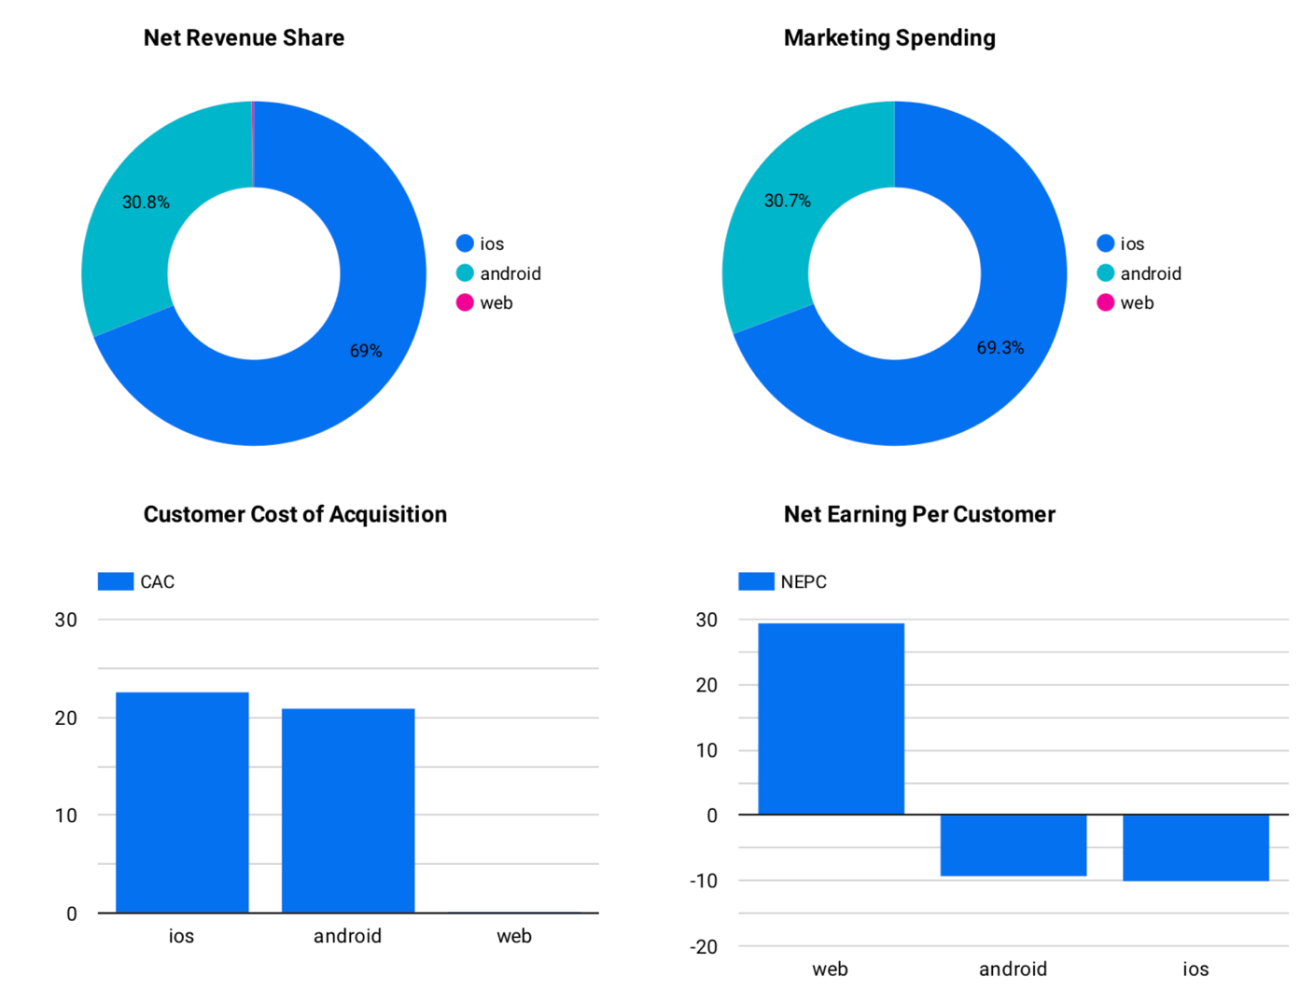

As it is seen above we have spent more in ios and consequently got more revenue from ios. It seems that revnue and marketing spending are highly correlated. In terms of CAC android is doing better. CAC for android is around 7% lower than ios. Also, Net Earning per Customer is 8% less negative for android than ios, which means that marketing ROI would be higher in ***android***.

**Therefore, I suggest to invest more in android.**

**Question 2. Is there any specific marketing channel we should be aiming for to get better results? I'm currently thinking that the channel with ID 4 looks promising. What are your thoughts?**

**Solution:** As it is understood from the data, there are some paid and unpaid channels available. So, I would answer to this question for paid and unpaid categories separately. I have also defined a new KPI, Marketing Spendings/Revenue, which could be an indicator of marketing ROI in each channel. The lowest the Marketing Spendings/Revenue, the better.

#### Unpaid Channels:

Among unpaid channels, Channel with ID 1 is outperforming both paid and unpaid ones by far. An unpaid channel could be SEO, 8fit's Facebook page or instagram account, which is a cost efficient and organic way of marketing but the drawback is that it takes time and you need to spend a lot on making content. For a startup, rapid growth is of a great importance, therefore, it is better to invest in paid ones like inbound marketing which is also cost efficient.

#### Paid Channels:

#### *It seems that Channel with ID 2 is the one doing better than other paid channels; as it has the highest revenue share and lowest CAC among paid channels. Therefore, I would invest in channel 2.*

Apart from channel 10, channel 2 has also the lowest Marketing_Spending/Revenue among other paid channels. I would not choose channel 10 because of its low revenue share. From my point of view channel 4 is not a safe bet, as it has a high CAC and high ratio of marketing_spending/revenue compare to channel 2. **I would invest in channel 2.**

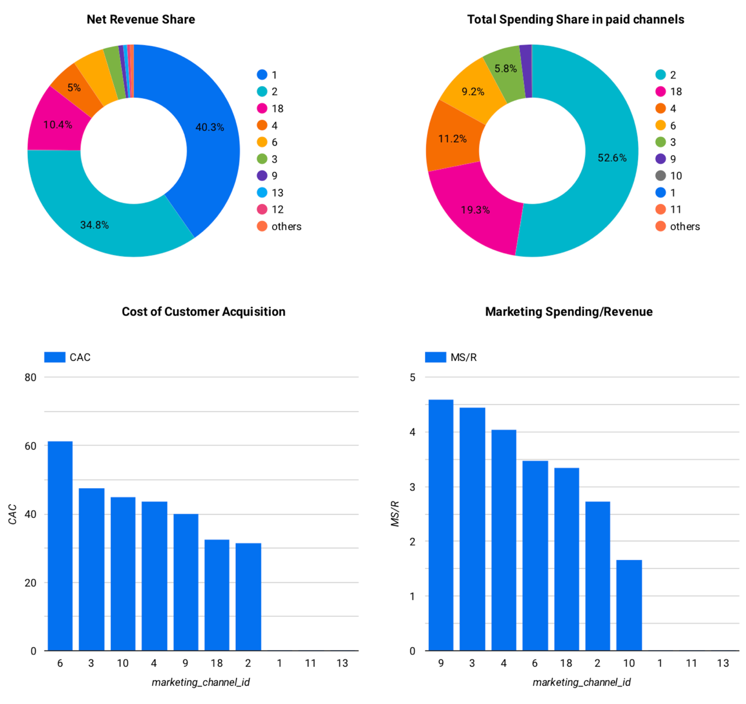

**Question 3. Looking further into the data at hand it looks like UK (United Kingdom) would be a good investment. Do you agree?**

**Solution:**

To certain extent, my answer to this question depends on 8fit's strategies. Whether it is :

* Market share growth: in this case we should focus more on CAC, and choose countries with lower CAC.
* Having higher ROI: in this case MarketingCost/REvenue would be more important.

Looking at below map, which shows 8fit's relative marketing spendings per country, it seems that it's target markets are:

* 1.North America
* 2.Europe
* 3.Australia
* 4.Latin America

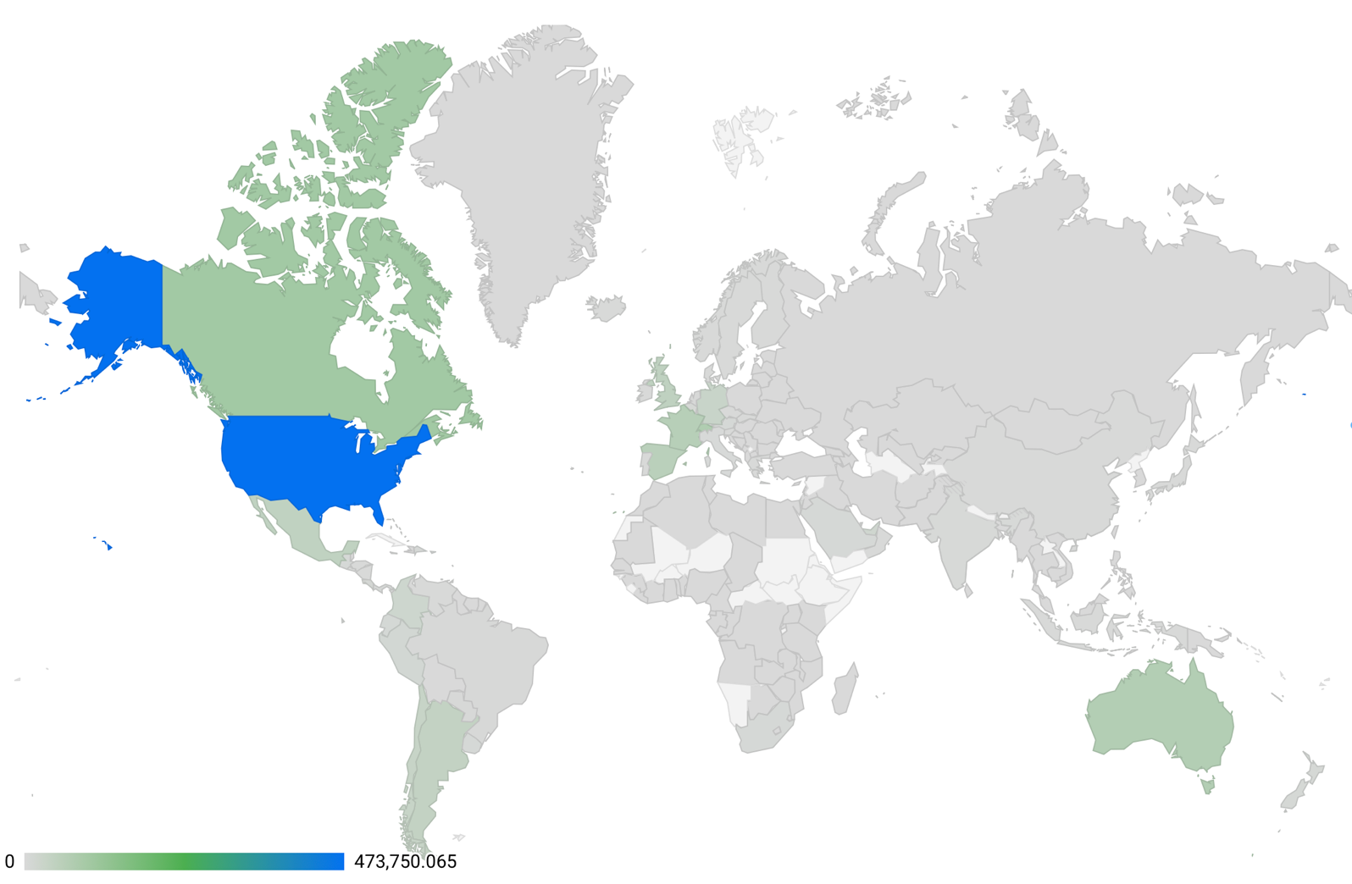

Having aggregated the data on the countries level, I sorted them based on net_revenue.

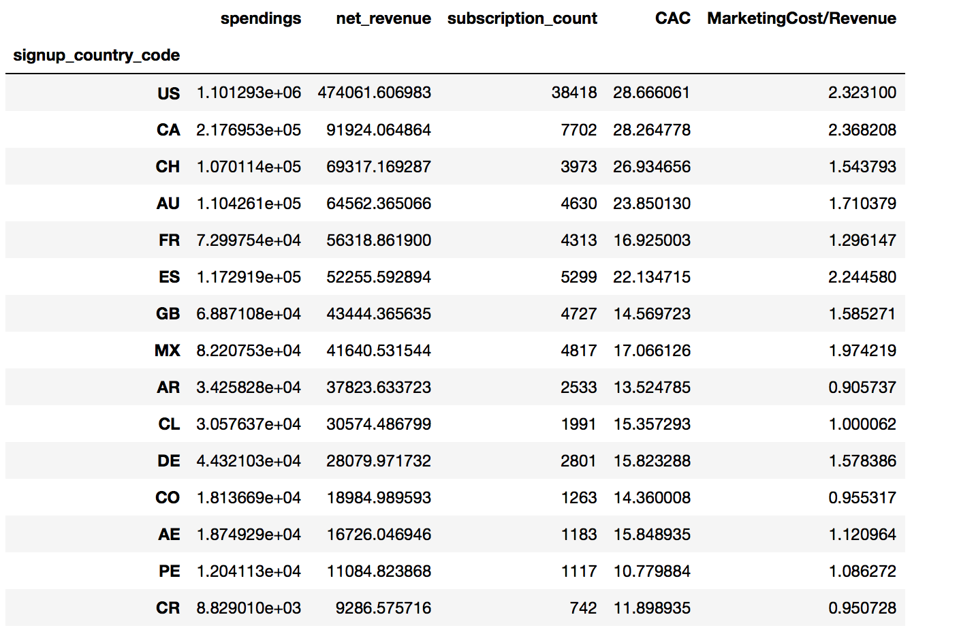

#### Argentina might be a choice?

Among the 15 top countries with highest revenue share AR, Argentina, seems to be an intersting oppotunity. As it shows a low CAC and MarketingCost/Revenue, which means that it would be a profitable market with a high marketing ROI. The only drawback is that Argentina economy has not been stable recently and the exchange rate has been fluctuating a lot, therefore as it exposes high risk to our investment I would not invest there.

UK which is available as GB in this dataset seems also a nice choice for Market share growth, but in terms of Marketing ROI, France seems a better one.

##### *Overal, if we aim to invest in Europe, UK would be a promising choice for gorwth, and France a good choice from a financial point of view. As for startups market share growth is crucial, I would suggest to invest in UK.*

### **Yes, I agree that UK is a good choice.**

**SQL Question**

I did not use the docker setup, therefore; I loaded the two datasets into two tables, subscriptions and spendings, in my local postgresql and did the query.

1. **How much did we spend per channel in December?**

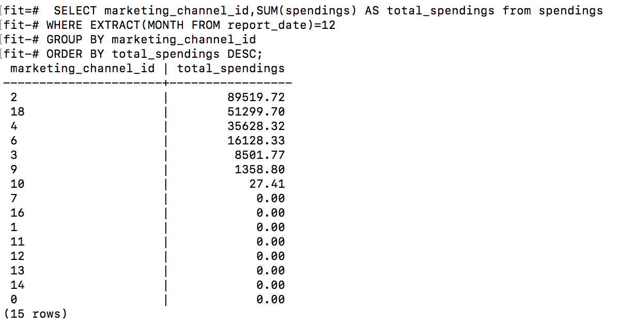

1. **What is the average cost of acquisition for a subscription per country?**

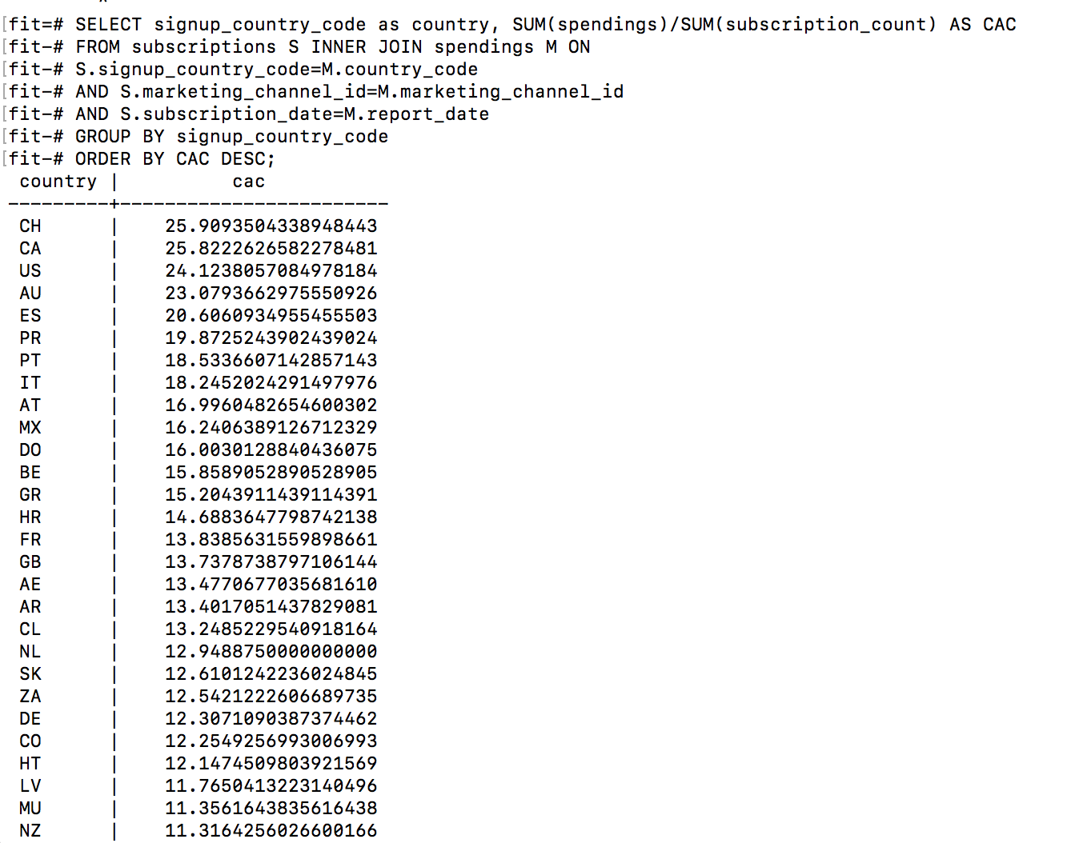

1. **What is our average revenue and spending per day of the week (Monday, Tuesday...)?**

